My Portfolio Website

Name: Michael Ian Catindoy

Year/Section: BSCS 3-A

**Website Description:**

The Content of this website is my portfolio that requirements of my currently school. This website has a index.html file that display my brief introduction of myself. And it has a 4 navigations home, about, project and a contact.

**About.html**

In this page it shows my information and at the bottom it has a word “download my resume” it will direct you to my copy of resume.

**Project.html**

This page shows my recently project, hands on and assignments.

**Contact.html**

In this last navigation show my social media accounts and how you can contact me.

I created all of that using **hypertext Markup Language, Javascripts, Cascading Style Sheets.** Thank to my professor and the help internet. I use javascript to open other files and CSS to design and animate my website.

Url: [**https://iamianmichael.github.io/Portfolio.github.io/**](https://iamianmichael.github.io/Portfolio.github.io/)

Images:

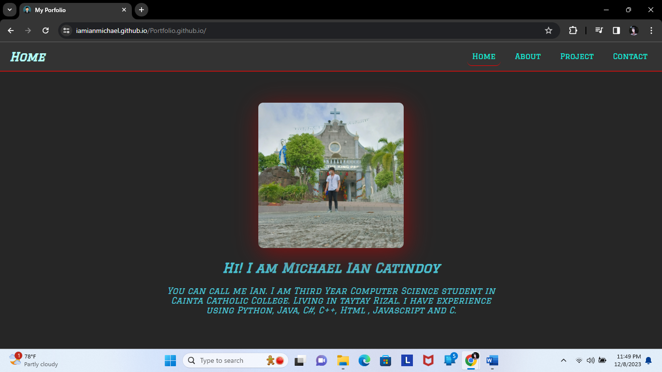Index.html

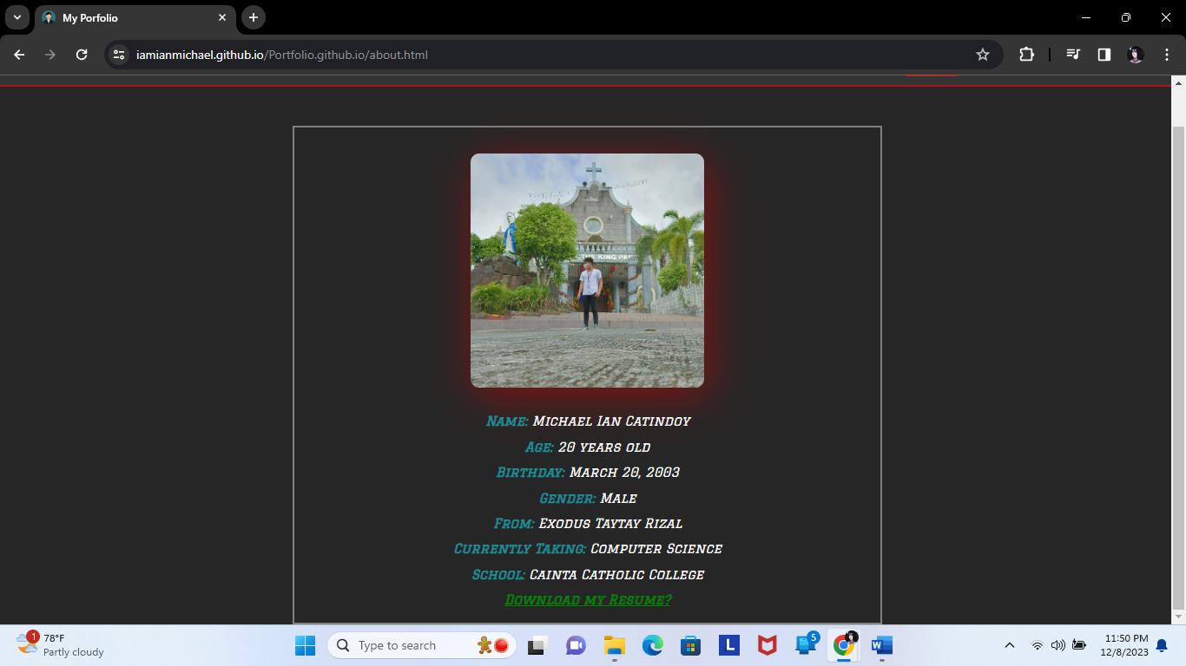About.html

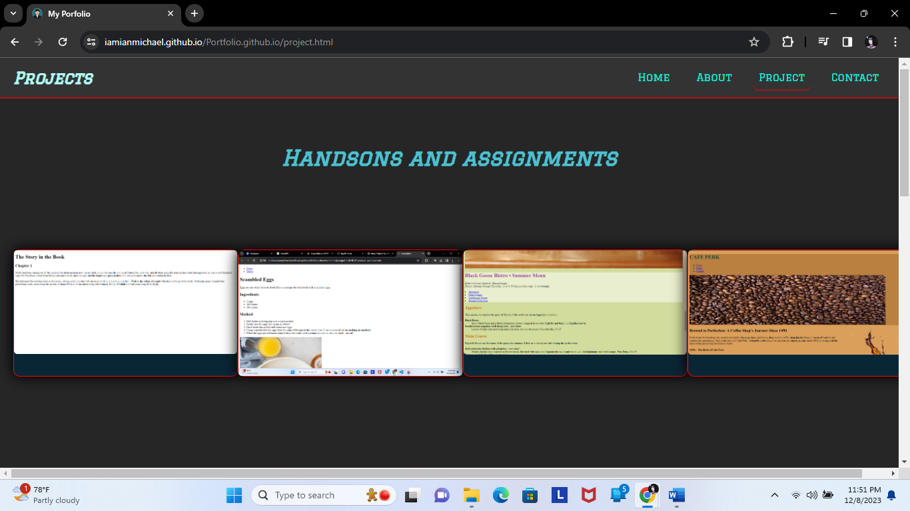Project.html

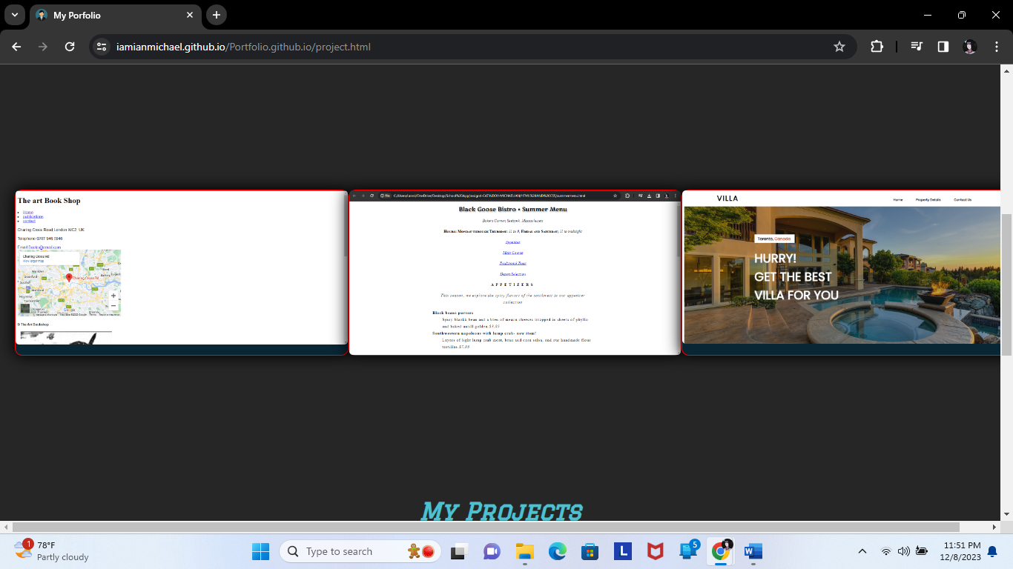

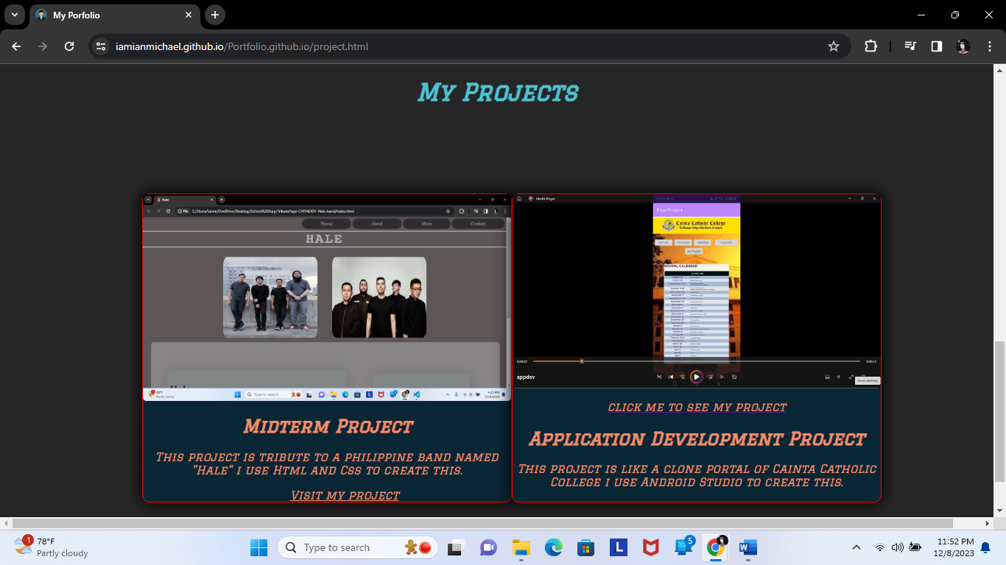

When view my project

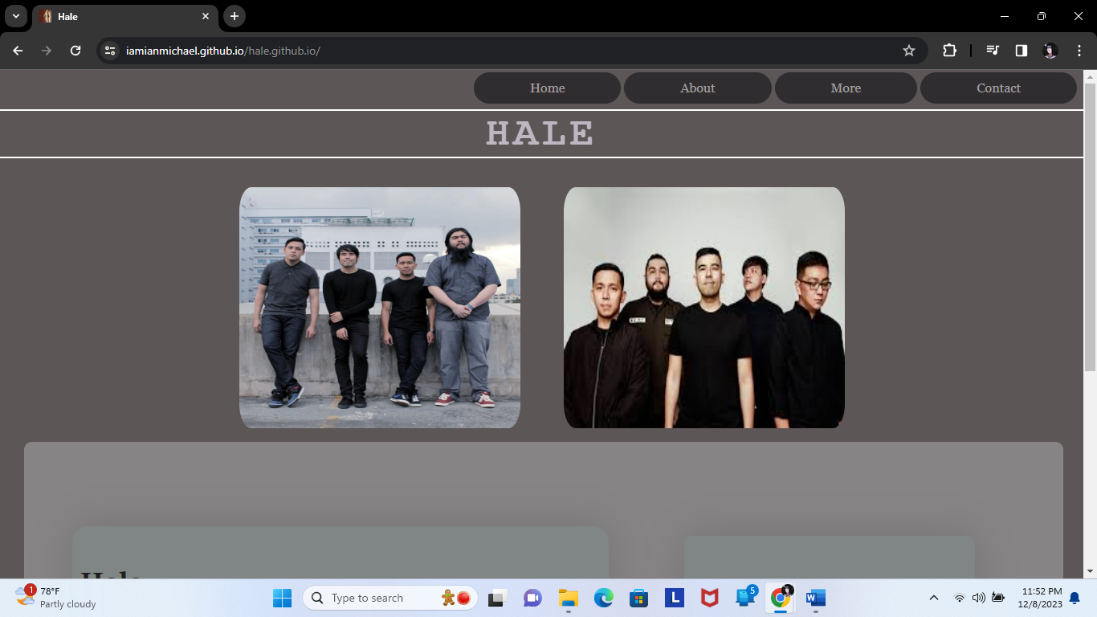

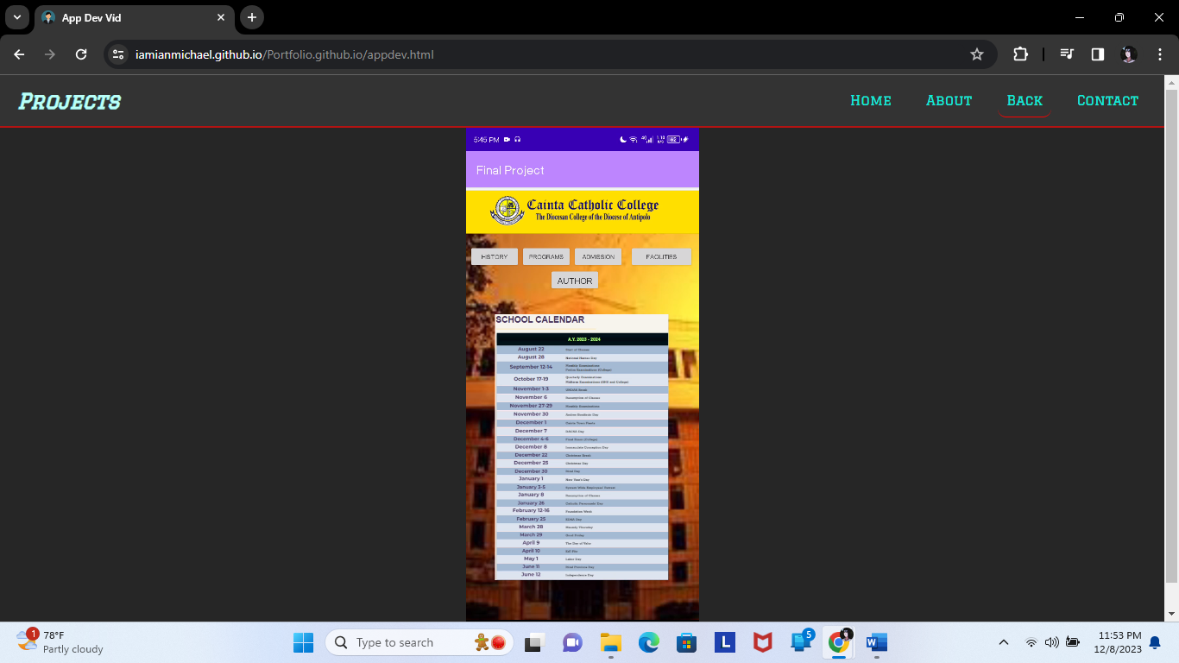

Contact.html

